Chat Bot Creation Steps

1. I am used Google colab for writing python code for creation of bot. And save it the name Chatbot.py.

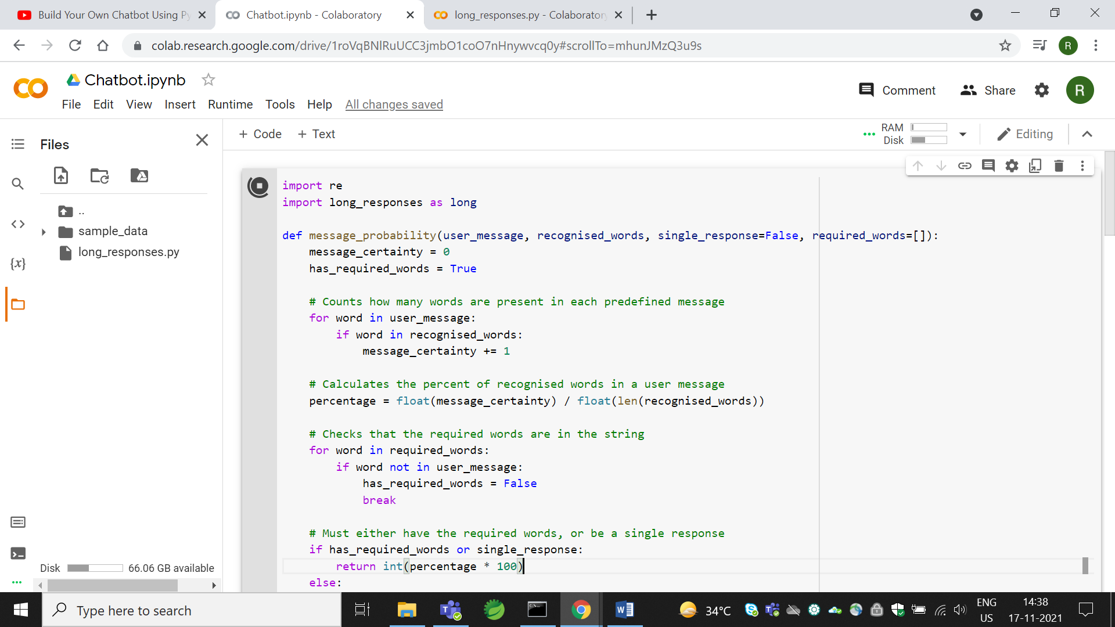

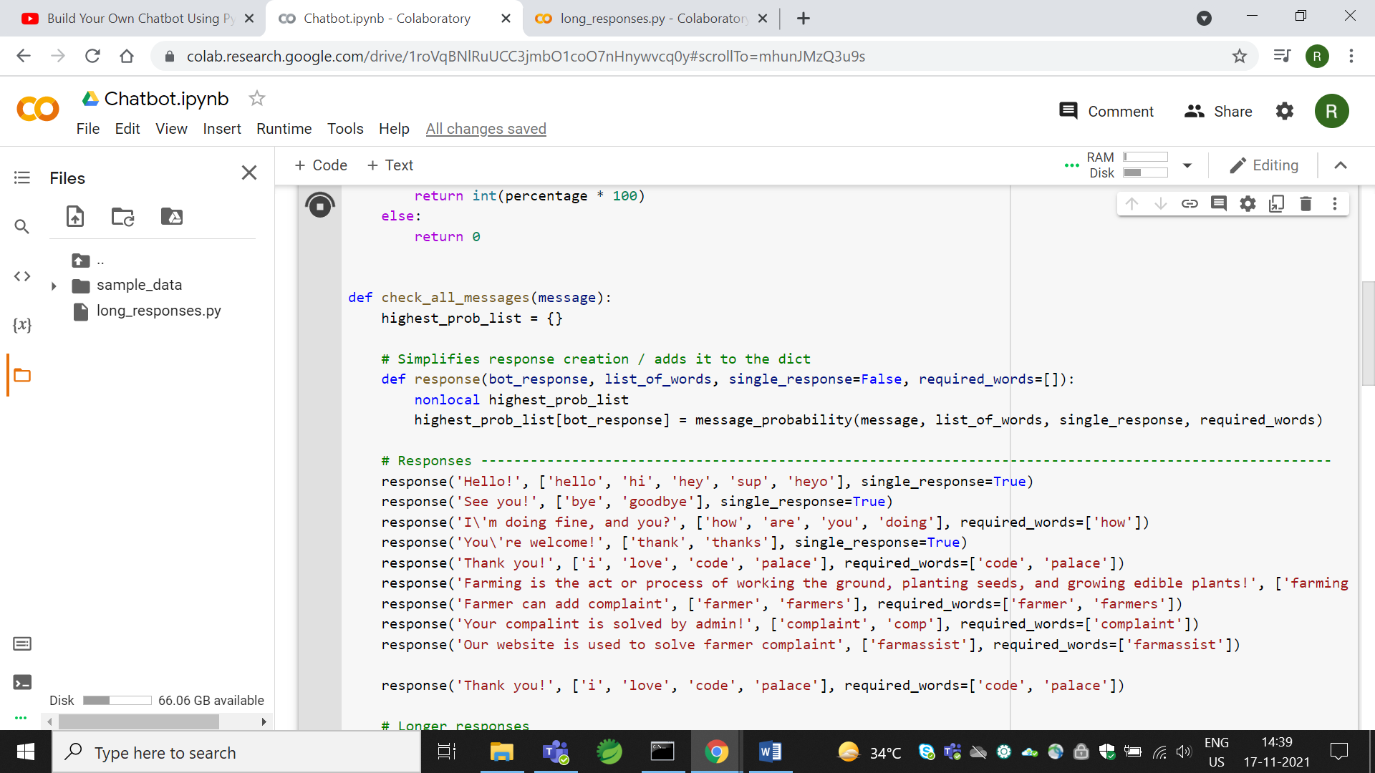

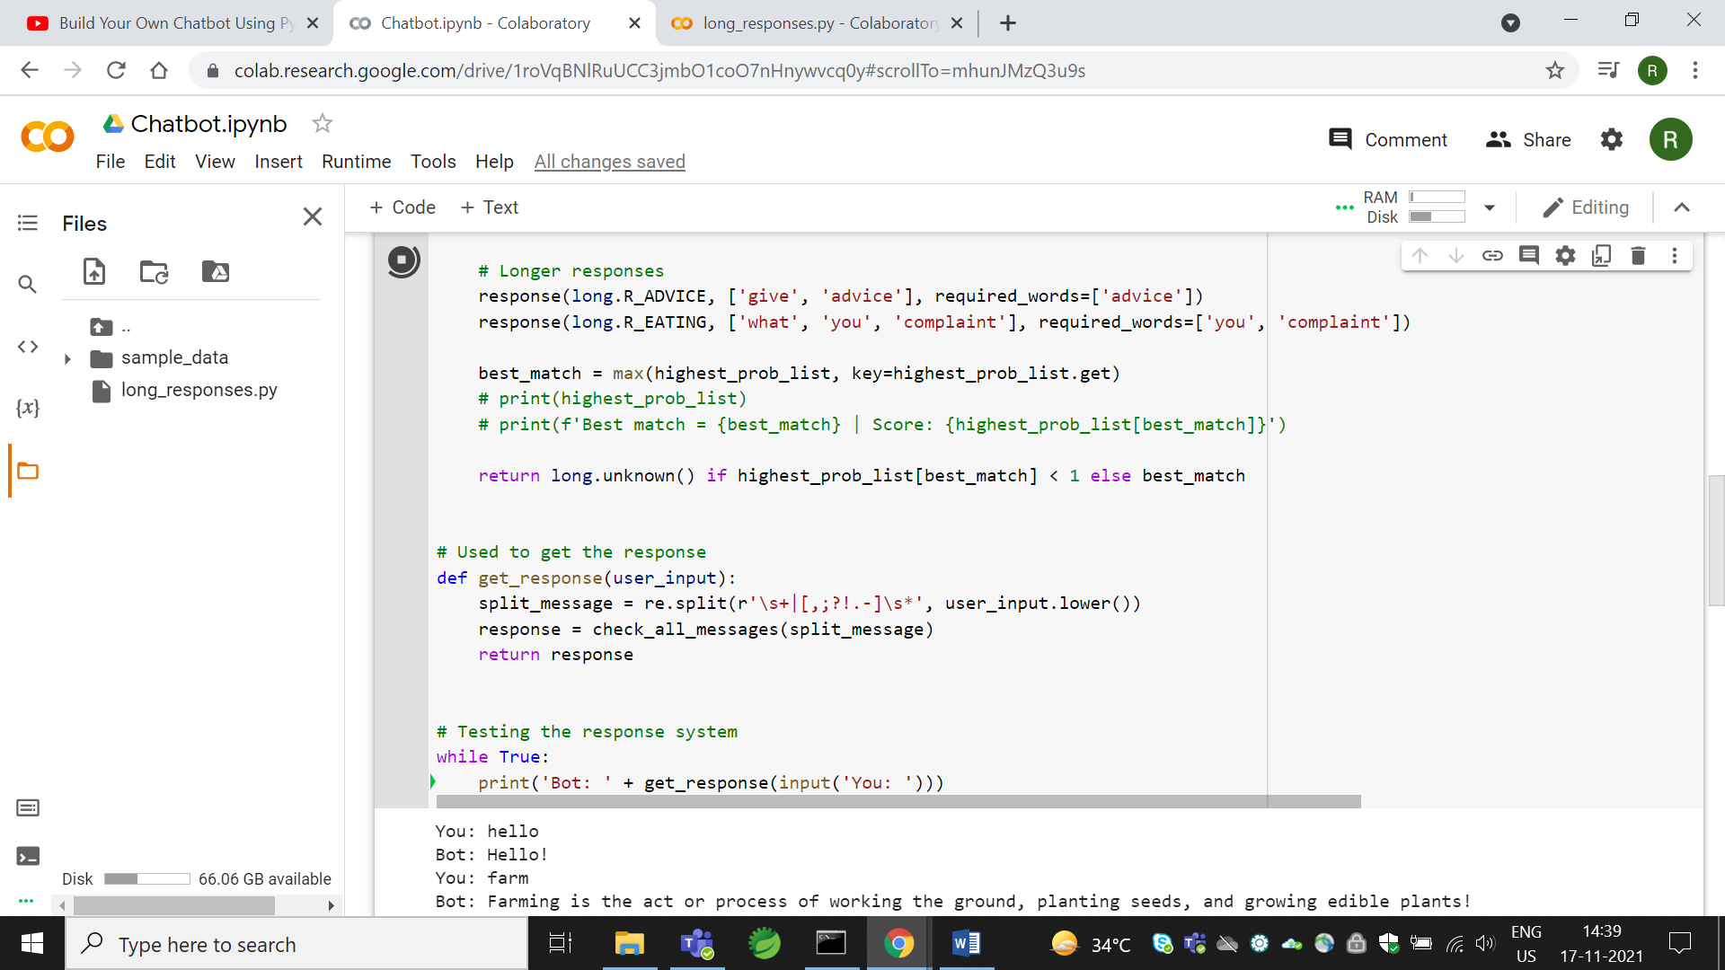

1. Created one more python file with the name long_responses.py and that file gives as the input to that Chatbot.py file.

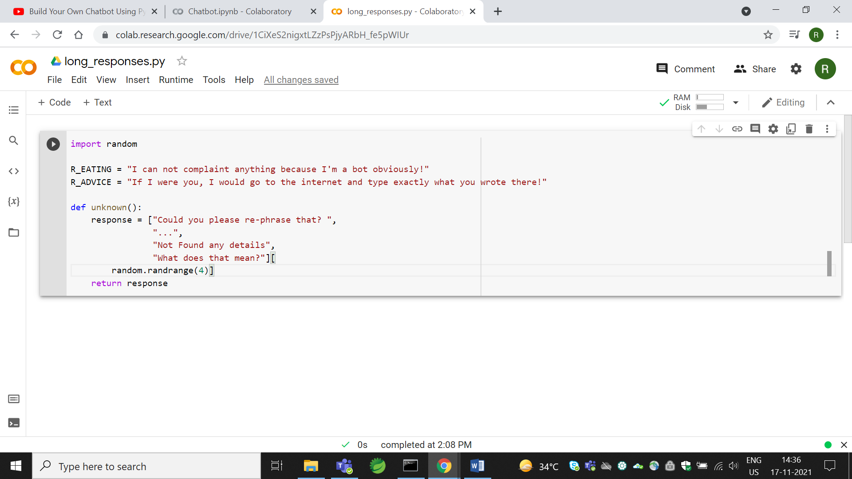

1. Click on Run🡪Runtime all🡪see that output.

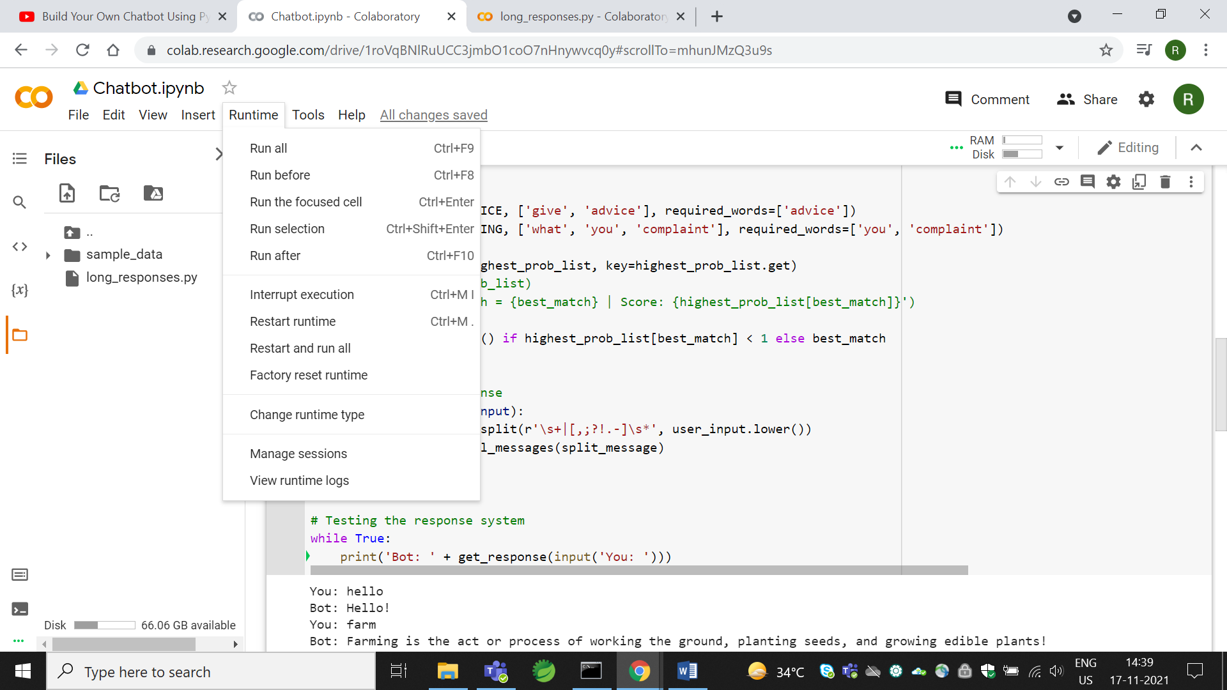

1. If you provide input to bot then it match it and on the basis of that it reply.

